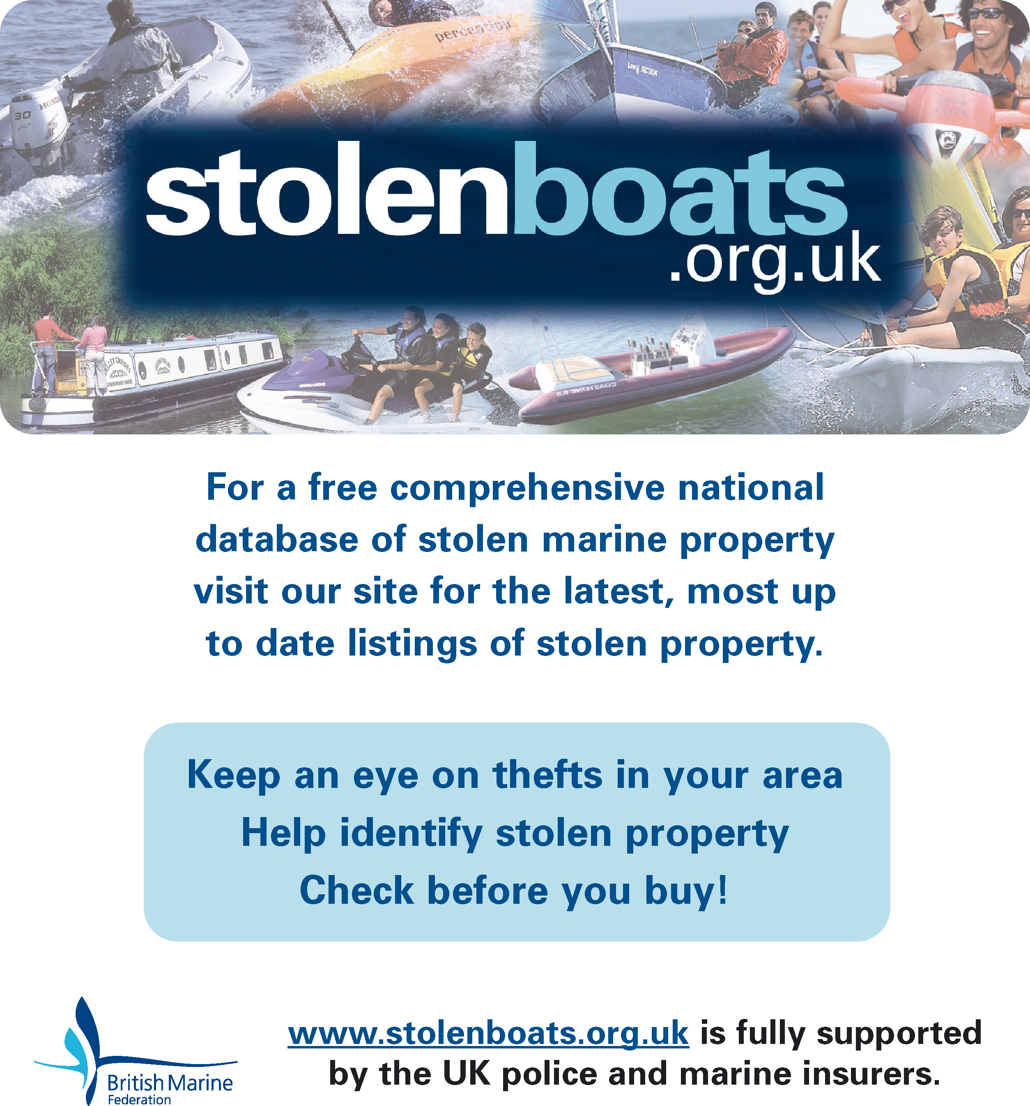

ENTER YOUR OWN CONTACT DETAILS, eg:
Contact your local police on
023 8023 6753
Hampshire Constabulary Marine Unit

ENTER YOUR OWN CONTACT DETAILS, eg:
Contact your local police on
023 8023 6753
Hampshire Constabulary Marine Unit

